When opening the Excel workbook, you will want to click enable macros. I use a Mac so my Excel may look different than yours, however you should still be able to find similar menus in the Windows version as well.

When you open the workbook, you will notice there are two tabs. The Cashflow tab is where you will want to put data into for the Macro to search out. The Expense Data tab is where the output of the macro will dump to.

To check out the code I have created for you will want to go to open up the Visual Basic Editor.

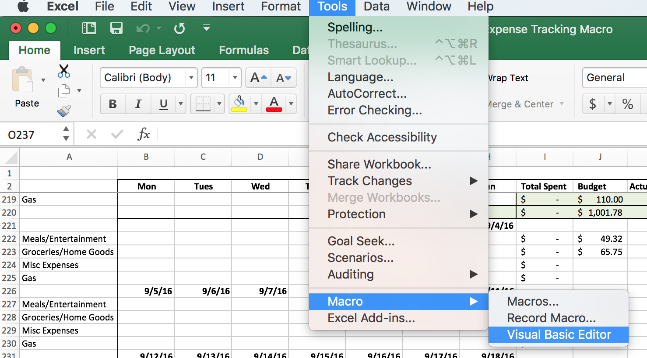

From here, you will want to open the workbook and then the Modules. Here you will find some notes as to what each section does.

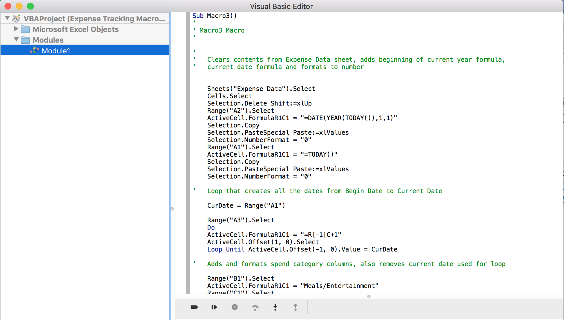

If you want to run the macro (you may want to input data on the Cashflow tab first) you can either do so via the play button at the bottom of the image above, or click the “Run Macro” button on the Cashflow tab.

